**[ROVR] Update: messaging and profile icons**

We’ve updated [ROVR](https://rovrapp.com) (Build 1.3, “Nikei”) with:

**Messaging**: You can now message your friends on ROVR (!!!)

**Profile Icons**: Choose from 115 new icons to use. Custom profile pictures are coming soon.

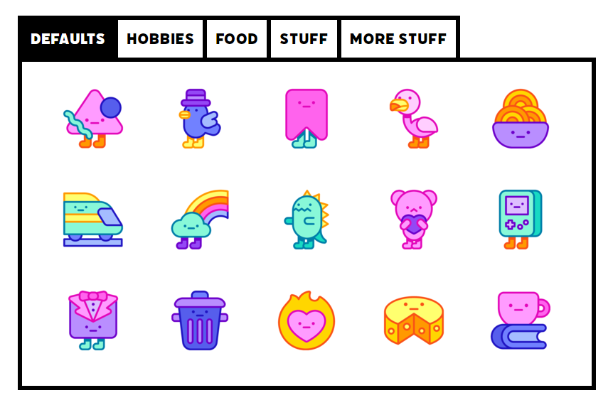

*Pictured: Profile icons vibing in your* [*profile settings*](https://rovrapp.com/settings)*.*

**Site tweaks**: More privacy options, a weekly email summary, dark mode toggle (in the site footer at the bottom of the website), and more in our GitHub.

**More invites:** You'll now have 10 closed beta invites. Join our [Discord](http://rovrapp.com/discord) and gain 10 more!

As always, you can send feedback, bug reports, or suggestions in our [Discord](http://rovrapp.com/discord) or through the red Feedback button on the website.

Happy ROVR-ing!

The ROVR Team

**Email template:**

**Subject: [ROVR] People want to meet you!**

[X] people waved at you this week on ROVR.

Visit your [notifications page](https://rovrapp.com) to check out their profiles and add them as a friend! Once you’re friends, you’ll be able to message each other and meet up in VR.

New friends since last week:  
[USERNAME]

Happy ROVR-ing!